St. Marguerite Bourgeoys School
2025-2026 Supply List
Grade 2 & 3
Item | Amount
Pencils (Staedtler – blue OR Ticonderoga brand) | 20
Erasers – plain white (Staedtler or comparable brand) | 6
Crayons 24 pk. (Crayola) | 1 box
Pencil Crayons 24 pk. – pre-sharpened, name on each one | 1 box
Markers – Washable | 1 box
Duo tangs – red/blue/green/yellow | 4
Dry Erase Markers, any colours (Expo brand) | 8 thin
Sharpie Marker – regular, fine point, black | 3
Sharpie Marker – ultra fine point, black | 1
Highlighter | 2
Glue Stick – large (UHU or Elmer’s brand) | 4
Kleenex (tissues) | 2
Scissors | 1
Ruler – 30 cm | 1
Watercolor Paint Set – Crayola washable (24 colors) | 1
Pencil Case (soft) | 1 or 2
Pencil Box (hard) | 1
Pencil Sharpener (with container for shavings – Staedtler) | 1
Sketch Book (Dollar Stores have inexpensive ones) | 1
Disinfecting Wipes – Lysol | 1 pack
Baby Wipes | 1 pack
Hilroy Exercise Book – yellow: half ruled, half plain  72-page style (these are smaller sized than a regular sheet of paper) | 1
Hilroy Exercise Book – light blue: plain  72-page style (these are smaller sized than a regular sheet of paper) | 1
Headphones (not earbuds) | 1
Flashlight with batteries | 1
Indoor Shoes (non-marking) – preferably not laced.  If laced, students must be able to tie independently | 1
Backpack and Water Bottle | 1 each
1 inch binder | 1
Duotangs, sanitizer, cutlery, Kleenex, wipes | Provided by CSCC

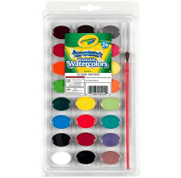
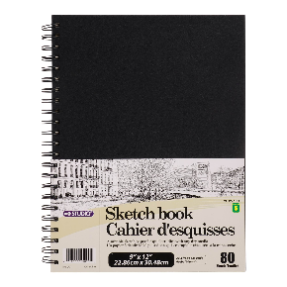
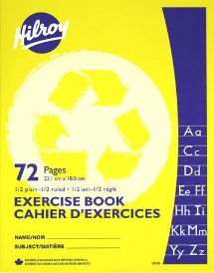
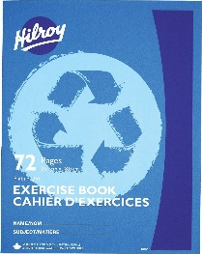
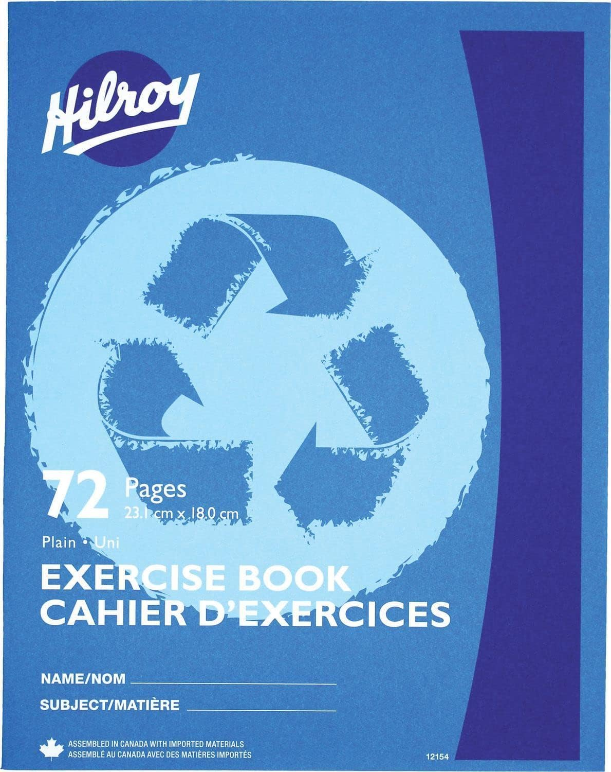

- (1) (1)
- Please, no scented products (hand sanitizer, etc.)

