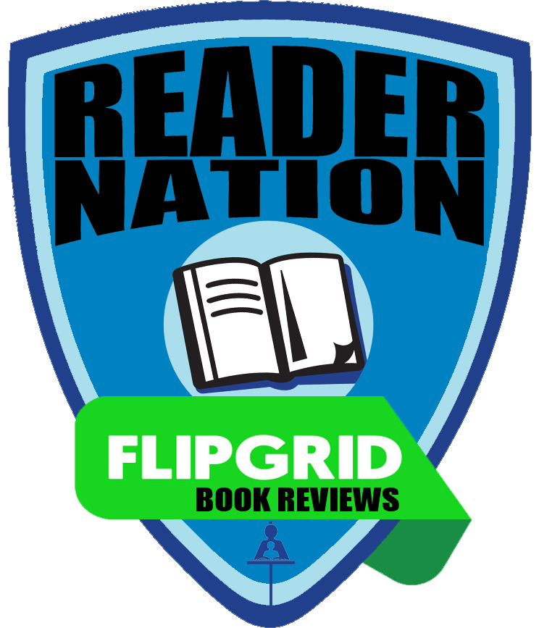
REVIEW | REFLECT | RATE | RECOMMEND
BOOK REVIEWS

- Open Flipgrid
- Use the code rcsdbook
- Enter the student ID or scan
the QR Code given to you

- Select your grade level

- Click to add your video
- Click to record your video. Wait for the countdown.
- Review:
  - What is the title? Who is the author? What is the genre?
  - Give a brief summary, but do NOT give away the ending! Make others so curious that they will want to pick up a copy!
- Reflect:
  - Make a text-to-self, text-to-text, or text-to-world connection.
  - How did this book impact you?
- Rate:
  - How many stars (out of 5) would you give this book? Why?
- Recommend
  - Would you recommend this book? For who?


- Click to pause/resume your recording

- Click to review your response

- Can you hear yourself clearly? If not, click to re-record
- You can click to trim your video from the beginning or the end

- Click if you are satisfied with your recording
- Click to snap your selfie with your book
- Click to proceed
- 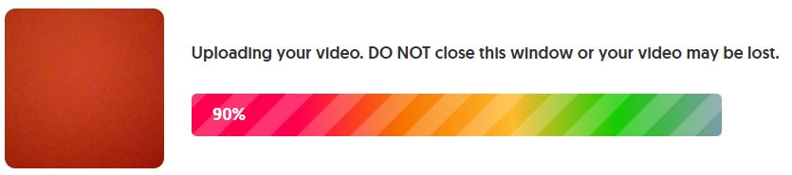Wait for your video to be uploaded
- means your video is uploaded
- 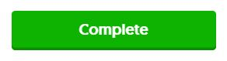Click

Once your teacher librarian has viewed your video, it will appear on the #RCSDbook grid for others to view!

